<Study Name>Study

Castor Connect

Participant Quick Start Guide

## 

## 

## 

## Welcome to the Study!

The Castor Connect app is an application that enables you to complete study assessments from the comfort of your own device.

You are able to complete your study tasks and submit your data directly to our platform for review and use as part of the <Study Name> study.

**Thank you for your participation. This data is very important for the study!**

Steps to download and use the app <Study specific screenshots>



|  |  |  |  |  |
| --- | --- | --- | --- | --- |

More details for each step can be found in the following pages.

## Downloading the App

You will be asked to download the app, you can do this by clicking on the link in the Invitation Email you may have already received, scanning the relevant QR code below with your phone’s camera or downloading the app from your phone’s app store:

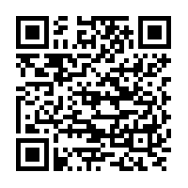 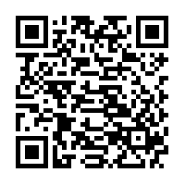

**Google Play Store** **Apple App Store**

1. Search for ‘Castor Connect’ in the app store
2. Select ‘Castor connect’ and begin your download

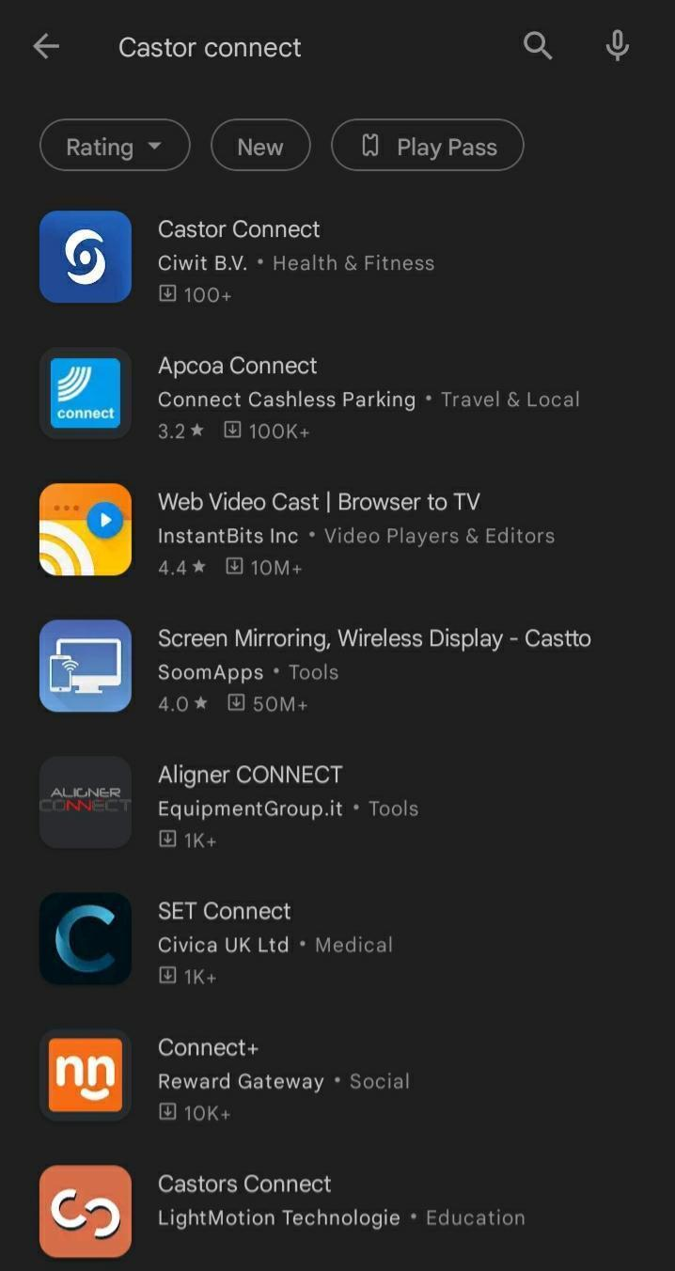 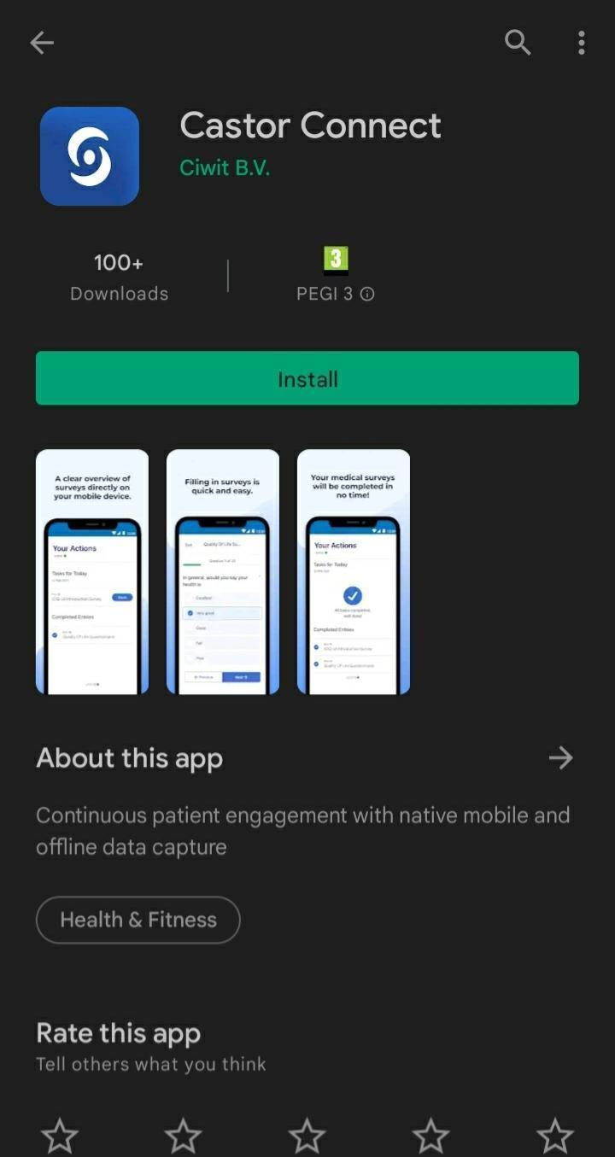

## 

## Account Activation

After downloading the app you must activate your account. There are two ways to activate your account:

1. **Email**

Select the link in the activation email using your device, this will open the app and automatically activate and allow you to proceed.

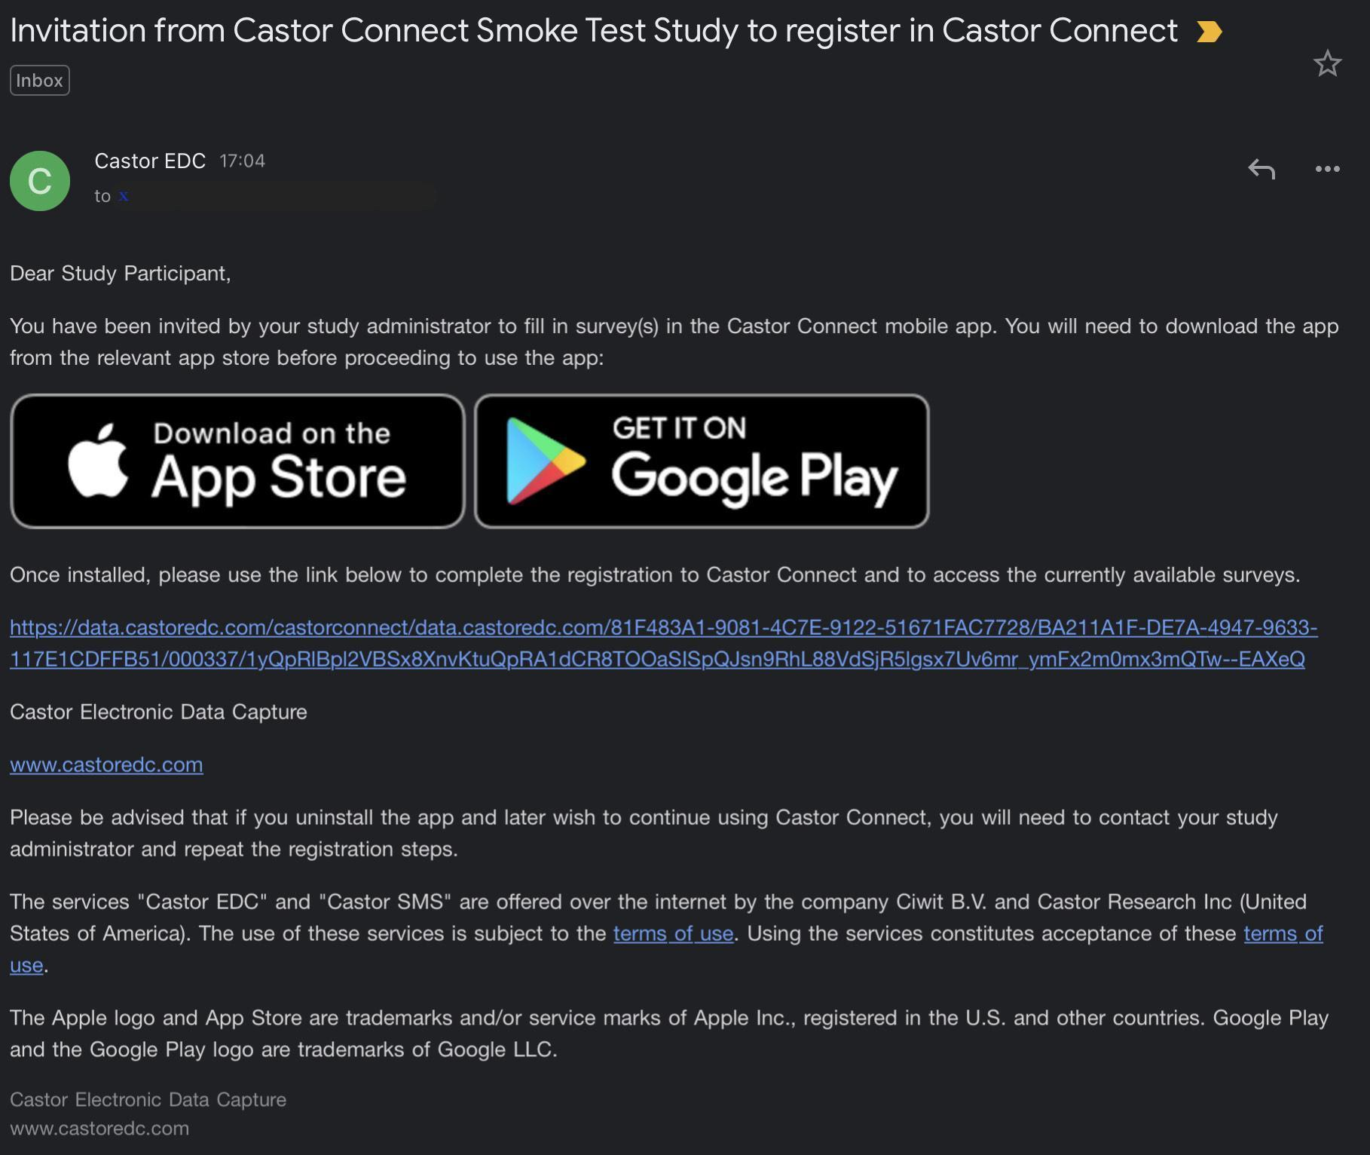

1. **QR Code**

Your site can provide you with a QR code that you simply scan using the scanning option on the activation screen in the app - the app will activate and allow you to proceed.

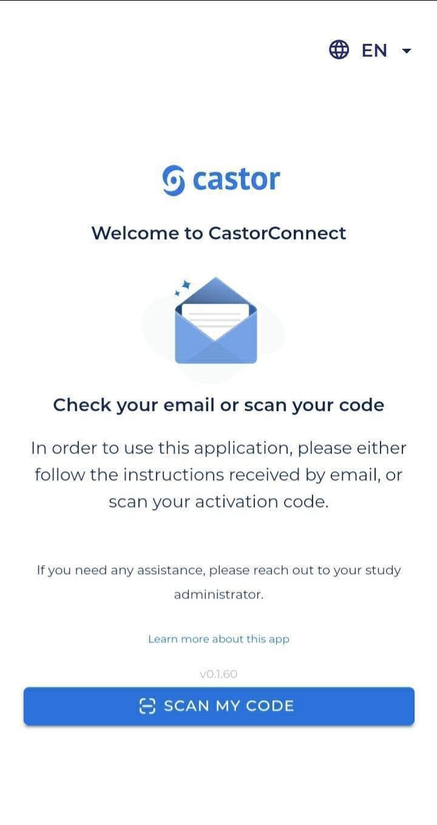

**If you change your device for any reason please contact your site to issue you a new activation code.**

**Links and codes are valid for 72 hours.**

## App security

You will need to create a unique 6-digit PIN. This PIN will be used to access the app if device security cannot be used.

### Creating your PIN

**Don’t share this PIN with anyone.**

### Device security

You can enable the app to use the same security method you use for your device day-to-day to access the application, for example an entered pattern, TouchID (fingerprint) or FaceID.

**Castor does not have access to any of your device security information and this does not leave your device.**

When using your PIN instead of native device security, you will need to have an active internet connection.

### 

### Resetting your PIN

If you have forgotten your PIN and cannot access the app, please use the 'Forgot PIN' link.

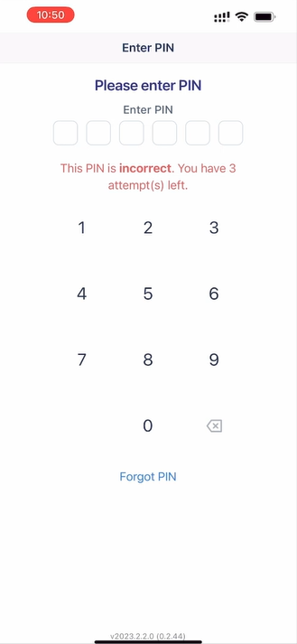

In the next step, following a message on screen use the 'Reset' button.

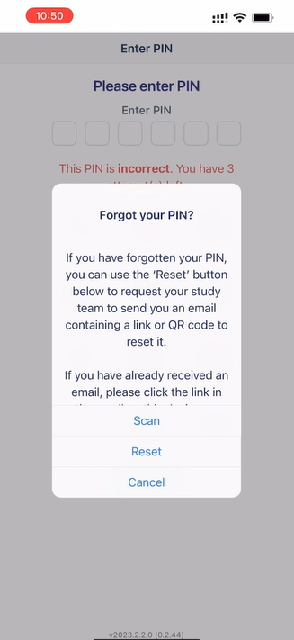 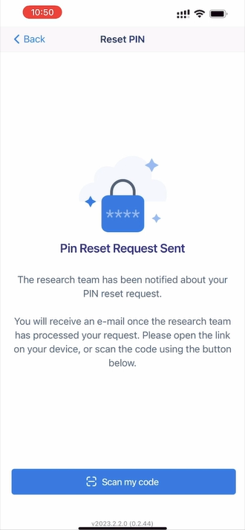

Then, you will receive the email with further guidelines.

The alternative option is to get in contact with your site. They will send a reset email to your registered email address.

In both cases, opening the link in the received email on your device will prompt the app to allow you to reset your security credentials and continue to complete your study activities.

### Completing assessments

When you log in to the Castor Connect app you will be presented with the home screen. Here you will be provided with an overview of any outstanding tasks and a list of tasks you have completed that day.

<Study specific screenshots>

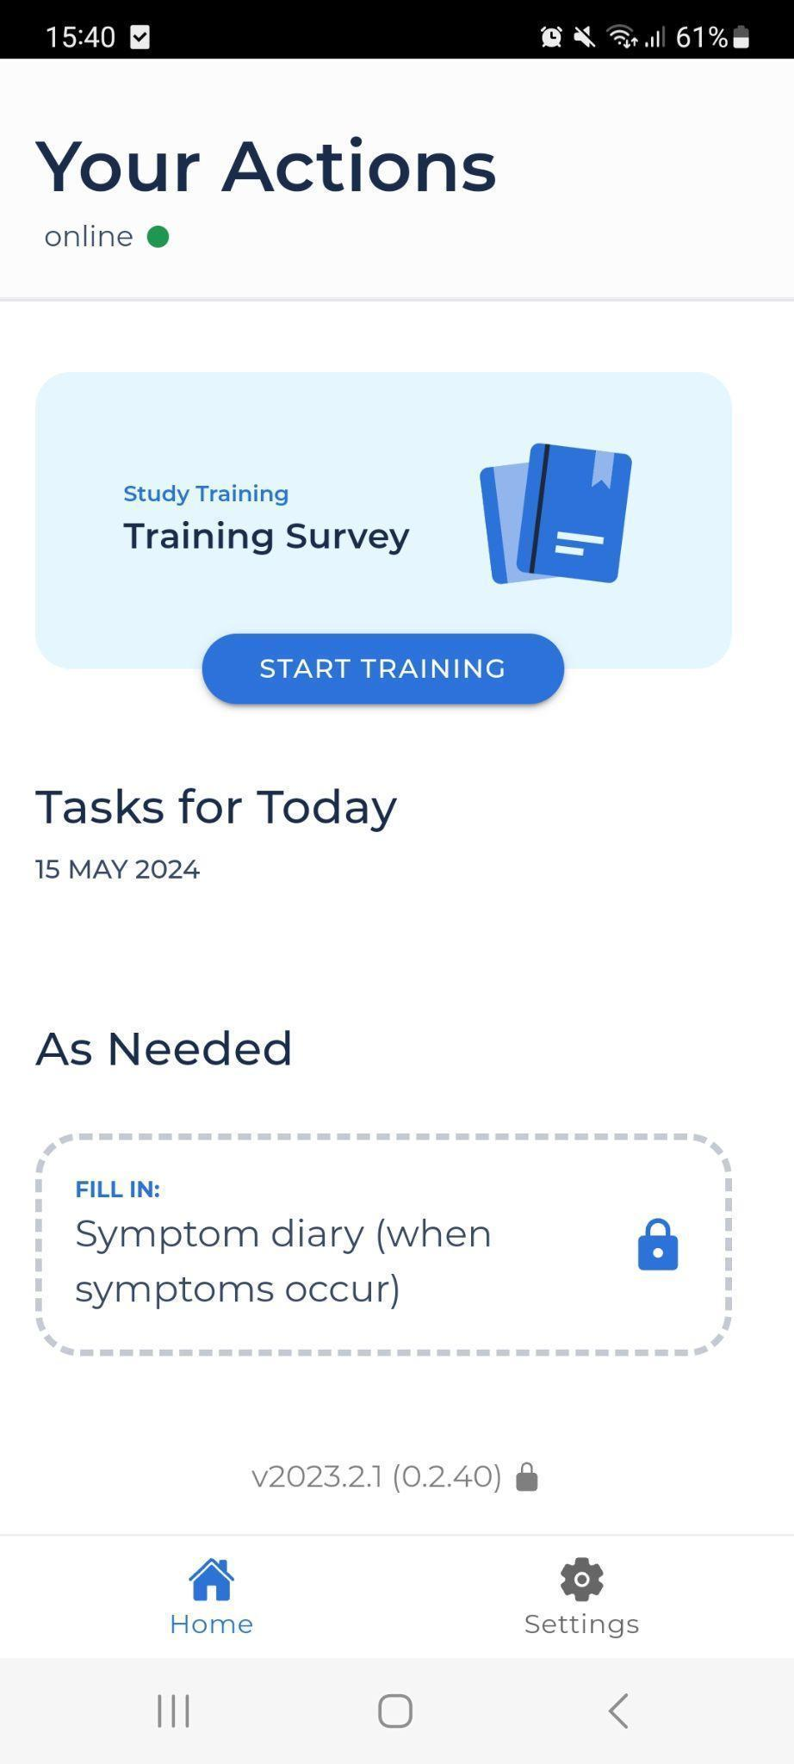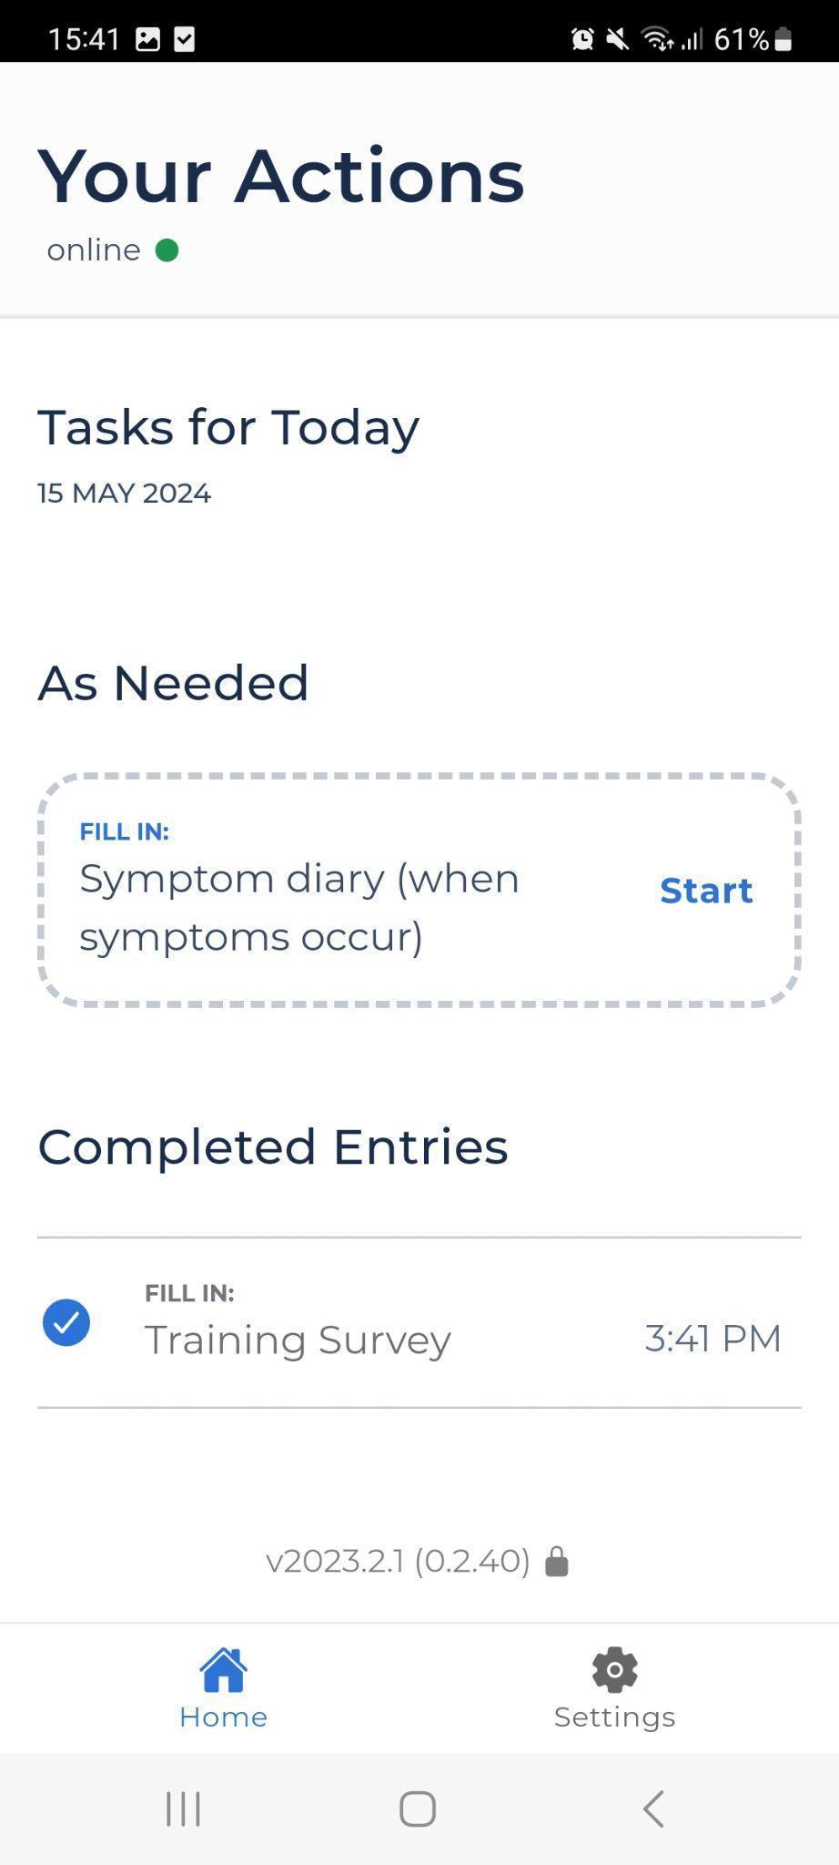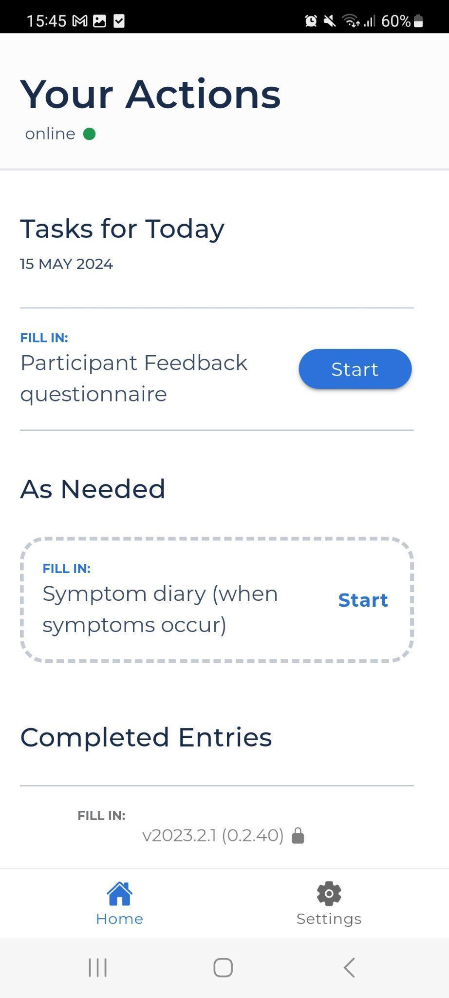

**All surveys will be locked on the app until the training survey has been completed**

Selecting ‘Start’ on a task will present you with the assessments that need to be completed.

### <Study specific settings>

### 

### **Training Survey**

This training survey will need to be completed before proceeding with any other study activities.

**Questionnaire 1**

Questionnaire 1 is completed ‘as needed’ meaning it will continue to always be available for the duration of the study.

**Questionnaire 2**

Questionnaire 2 is completed as per the schedule of assessments. Once completed for the specific visit it can not be completed again.

**To save your answers you must select ‘Finish’. Do not exit the app in the middle of completing an assessment; your answers will not be saved.**

## Data Sending

To ensure all data is sent after completing the assessments, your device should be connected to the internet via data or WiFi.

If you temporarily don’t have access to the internet, your completed assessments will be securely stored on your device. You can prompt your data to be submitted simply by re-opening the app.

Your data will be stored securely and reviewed by the study team that is assigned to the <study name> study.

## Re-installing the app

If you have a new phone or otherwise need to reinstall the app, you will need to re-activate the app. Your study site will send you a re-invitation link directly via email, or by providing you with a scannable QR code on request.

## Notifications/Reminders

## You will receive device reminders throughout the study, e.g; <daily, weekly, etc>

## This will appear as a notification on your phone. To remove the reminder from the app main menu, simply select ‘start’ and ‘finish’.

<Study specific screenshots>

## 

## 

## 

## **You must allow background running so the notifications will be sent.**

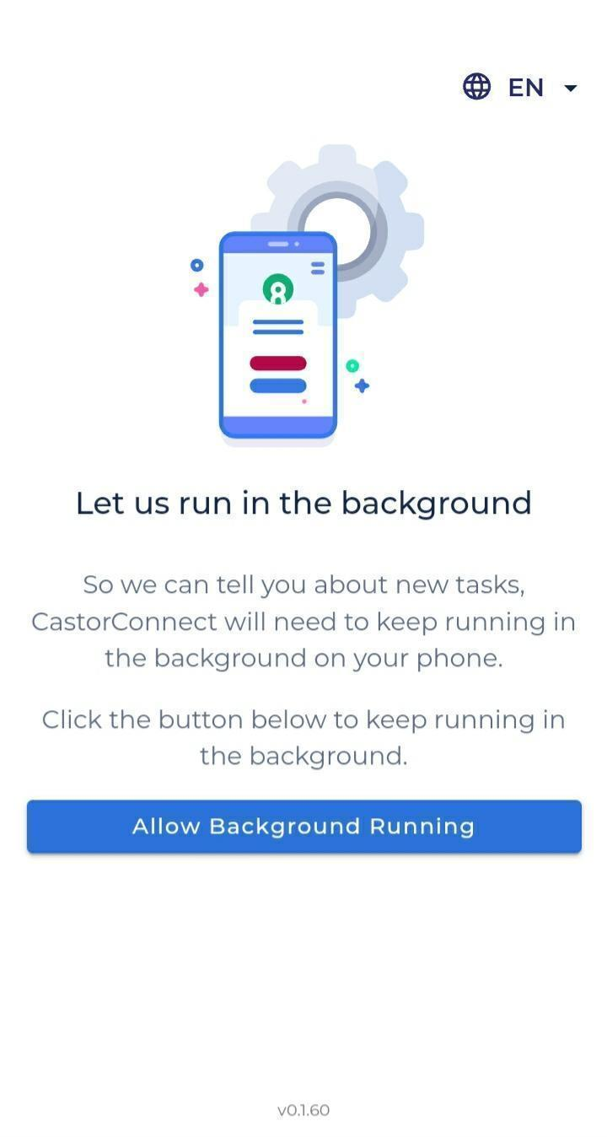

## 

## 

### 

## Deleting the App

Before deleting the app you must consult with your study site. Deleting the app from your device will clear any unsubmitted data and this will be lost.

## **Getting Support**

**If you have any questions or problems using the app please contact your study site to assist you.**